

**The balance of growth**

Speech given by

Ben Broadbent, External Member of the Monetary Policy Committee, Bank of England

London School of Economics 17 January 2014

I would like to thank Alina Barnett for research assistance and I am also grateful for helpful comments from other colleagues. The views expressed are my own and do not necessarily reflect those of the Bank of England or other members of the Monetary Policy Committee.

The UK is economy is growing, and will probably have done so at an above-average rate in the second half of this year. Coming only a few months after fears of another (“triple dip”) recession, the rebound in economic activity is very welcome.

Now that it’s here, however, concerns about the absence of growth have been replaced with worries about its composition: too much consumer-led spending, too little investment and trade. In particular, it is argued, the recovery will run out of steam without a rise in investment because of an ongoing contraction in real wages. The suggestion is that proceeds of growth are being diverted to unspent corporate profits. Growth is therefore caught in a nasty scissor movement between a decline in real wages, which limits the room for further growth in household spending, and perpetually stagnant business investment. As a result it is destined to subside. My aim today is to ask whether this view holds up to scrutiny.

I will make three points. The first is that real pay is weak not because firms are taking (and hoarding) the lion’s share of the proceeds of growth – in fact, the opposite is true: wages have grown faster than profits during this recovery – but because the prices we pay for consumption have risen much faster than those firms receive for their output.

This trend in relative prices began long before the recession and has nothing to do with monetary policy. Instead, it reflects a variety of things which, having moved strongly in favour of the UK during the first decade of inflation targeting, then moved firmly against us during the second. The bad news for wage-earners, therefore, is that the usual cyclical expansion in profit margins has yet to occur. The good news – good for the consumption value of national, not just wage, income – is that these relative price trends may now be abating.

The second point is about the typical sequencing of economic expansions. Business investment tends to lag, not lead, the cycle in output (the opposite is true for housing investment). One of the reasons firms’ capital spending has stagnated is that the recovery has so far been too weak to allow their profits to recover. But history, and a variety of indicators, suggests it is likely to accelerate through this year. Indeed, allowing for measurement error, it may already have started to do so.

The final and more general point is to caution against inferring too much about future growth from its current composition. Of course there’s a risk the recovery could falter. But, if it does, it will probably be because of more fundamental problems – a failure of productivity to respond to stronger demand, for example, or continuing stagnation in the euro area – not any imbalance in expenditure or income *per se*. These are outcomes, not determinants, of the economic cycle. As we shall see, they are poor predictors of future growth.

# Weak real pay: relative prices, not reallocation of income

Let us begin with the stagnation of real wages. Real GDP is now 6% higher than at its cyclical trough in mid-2009. Yet, deflated by consumer prices, average earnings have fallen by over 4%1. Even if you take account of the relatively strong (3%) growth of employment over that period – allowing, in other words, for the weakness of productivity growth – there is still a big gap between the two. Output is significantly higher than at the trough of the cycle yet, even in aggregate, real wages are lower than they were four years ago (Chart 1). The impression conveyed by many commentators is that there must therefore have been a transfer of national income, away from wages and towards profits. It is this drain on household income that is said to threaten the sustainability of the recovery.

Even as a matter of principle it’s not clear this argument works. Profits don’t simply disappear into the ether: they are either retained within firms, to fund current or future investment, or they are redistributed, mostly via pension funds, to the households that ultimately own them. Post-tax wages constitute a little more than one half of households’ disposable income2.

When it comes to the data, the argument seems to me to get things the wrong way round, or at least to miss the point. The fact is that it’s entirely normal for profits to outgrow wages during economic recoveries – and normal expansions cannot (by construction) be abnormally short.

## Chart 1: Aggregate real wages have underperformed real output

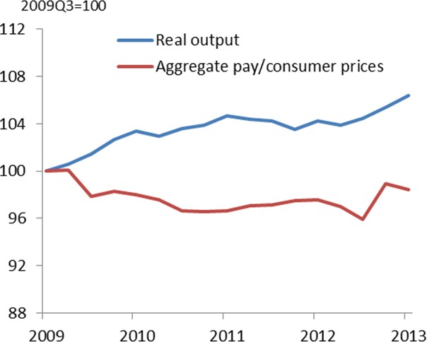

Source: ONS and own calculations

In fact, if we’re to be concerned by anything this time round, on behalf of wage-earners, it’s precisely that this recovery in profit margins has not yet occurred: at least in nominal terms, wages have done considerably better, not worse, than corporate profits over the past four years. This suggests that a rebuild of margins,

1 Deflated by the CPI, or by the deflator for aggregate consumption (CEX), the figure looks worse, by 2% points. But a significant contributor to that inflation, at least for the CEX, is the big rise in the estimated imputed rental cost of owner-occupation. You don’t need cash wages to meet this cost (it automatically gets added to households’ income, as their “operating surplus”) and, to derive a deflator appropriate for wages, it is right not to count this term. I exclude the numbers for imputed rent throughout this analysis, from both spending and output. Recognising that private consumption goods and services are provided by the market sector of the economy, I also exclude from output sectors O-Q (mostly public services).

2 A more subtle version of the argument rests on the assumption that companies or their owners are more inclined than wage-earners to save any extra income. The idea that “capitalists” save income and “workers” spend it is an old one in economics (Kaldor (1957)). But I don’t know of any proper test of it (see Deaton (1997) on this topic) and, on the face of it, the macroeconomic evidence is not that

supportive. Cyclically, margins are pro-cyclical: periods in which profits outgrow wages are associated with faster, not slower economic growth. Though other things might explain this correlation at cyclical frequencies, nor is there any link between growth and the profit share in episodes where there appear to be longer-lasting, secular changes in that share. It’s been rising for the best part of 20 years in the United States, for example, through good economic times and bad (Elsby et al (2013)).

which are mean-reverting in UK data, may yet have to take place. It also means that the recent underperformance of real wages, relative to real GDP, has a wholly different explanation.

## Chart 2: Firms’ margins are cyclical3 Chart 3: Gap between output and real wage

**growth typical after recessions**

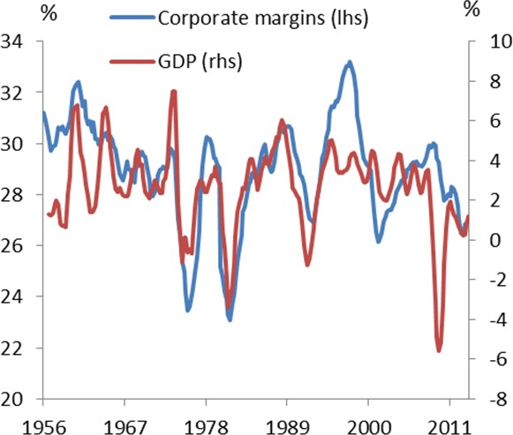 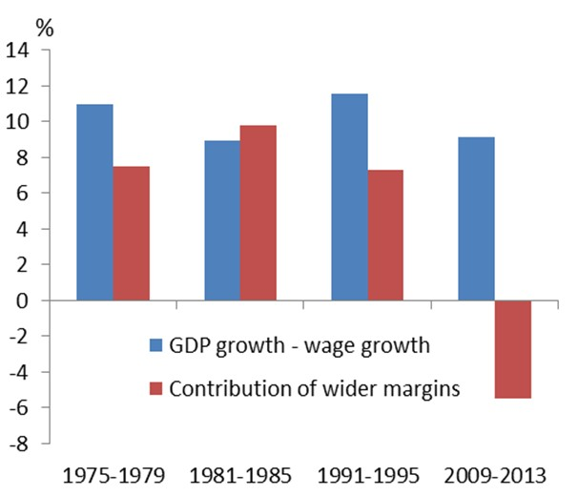

Source: ONS and own calculations Source: ONS and own calculations

Let me expand on these points with the help of some graphs. Chart 2 plots gross profits margins – the share of profits in pre-tax income – against GDP growth. Margins tend to fall in recessions and rise in recoveries. That’s why, in the early stages of typical economic expansions, wages underperform GDP. Chart 3, which focuses on the four years after cyclical troughs, makes this clear. The blue bars plot the cumulative gap between real GDP growth and real wage growth over those periods. The red bars show the contribution to that gap made by improving margins (the extent to which profits outgrew wages).

So the underperformance of real pay in the past four years is entirely unexceptional: the rightmost blue bar is in line with other post-war recoveries. What is exceptional is the red bar. In nominal terms – measured on a like-for-like basis – profits have actually underperformed wages. Contrast Chart 1 with Chart 4, its equivalent in nominal terms. It is capital income that has underperformed, especially if you include that on overseas assets.

And the cause of the difference between Chart 1 and the top two lines in Chart 4 – some of you are probably ahead of me here – is a big shift in relative prices. What UK residents pay for their consumption has risen much faster than the price UK firms get for their output. Since the trough of the cycle, the first has risen by 11% in past four years, an average rate of growth well above our target for the CPI. But the second has

3 These are adjusted for the emergence of North Sea oil in the late 1970s and early 1980, where capital intensity – and therefore gross operating margins – are extremely high. The unadjusted series shows a step jump in 1980.

barely risen at all: the average price of firms’ output is barely 2% higher than it was in the middle of 2009, less than that if you exclude North Sea oil. Firms simply haven’t been able to afford much in the way of wage increases.

## Chart 4: In nominal terms, wages have done better than output, significantly better than capital income4

**Chart 5: Most of the rise in consumer prices has not gone to UK firms’ profits**

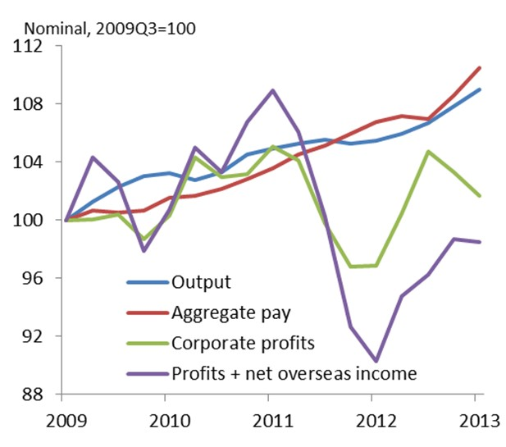 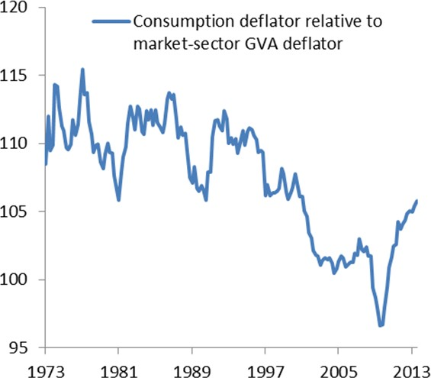

Source: ONS and own calculations Source: ONS and own calculations

This relative price – what I will call the “real” price of consumption – is shown in Chart 5. The 9% increase since the recession ended has more than absorbed the rise in the volume of output since then. As a result, it’s not just real wages that have stagnated relative to GDP: the real income of the private sector in aggregate has also failed to grow. Measured in terms of its consumption value, it’s 2½% lower than it was four years ago.

To supplement the graphs, it may help to make the same point symbolically, using a simple stylised decomposition:

*real average pay growth = productivity growth – growth in margins – growth in real consumer prices*

After recessions it’s not unusual to see aggregate real wages underperform real GDP (and equivalently, dividing both by employment, average real pay underperform productivity). Typically it’s the second term on the right-hand side that drives a wedge between the two. In the past four years, however, margins have actually gone in favour of wage-earners. What’s done the damage is the third term, a steep rise in real consumer prices. It’s this, coupled with weak productivity, that has prevented real average pay from growing.

4 Again, remember that by output I mean the value-added of the market sector of the economy – everything except public services (as measured by sectors O-Q) and imputed rent on owner-occupied housing. The same is true of my definition of private-sector income.

Before trying to understand why this jump in relative consumer prices has occurred, let me first make a more negative point and say what I think is not to blame – and that is monetary policy. I often read that real pay is weak “because” CPI inflation has been above target. To me, this makes little sense. One of the first things one learns in economics is that, over time (in the “long run”), purely monetary disturbances shouldn’t have first-order effects on real quantities. That includes real (i.e. relative) prices: loose monetary policy might encourage faster inflation in general, across all prices, but there is no reason to expect it to affect one particular price much more than any other.

Nor is it this just a theoretical quibble. As you can see from Chart 5, the real price of consumption fell sharply during the second half of the 1970s, at a time when overall inflation was very high. You see a similar pattern in the second half of the 1980s. So it cannot be right to blame recent rises in real consumption prices on above-target inflation if they also declined during periods when inflation was much higher5.

By this I don’t mean there’s no link at all between real consumer prices and the overall rate of inflation, at least in the near term. Nor would I wish to dodge the fact of above-target CPI inflation in recent years. But most economists would argue the link runs the other way round: if people resist a hit to real incomes, it may lead them to try and recoup those losses through faster growth in wages, putting upwards pressure on overall inflation. What ultimately happens to inflation is still the responsibility of the monetary authority. It’s just that a squeeze on real incomes makes it somewhat harder to keep a lid on those pressures. Favourable shocks to income, conversely, provide what Charlie Bean once called a “favourable tailwind” for central banks6.

It’s the real income shock that comes first, however, and the thought experiment that says “if monetary policy had succeeded in keeping CPI inflation at target real wages would have been higher” is therefore not a valid one. Instead, other prices – including the price of non-oil output and nominal wages themselves, both of which have flirted with deflation in recent years – would probably have fallen.

So rather than looking to monetary policy, I think the answer lies in a whole host of other factors – real things

– that have driven an unwelcome wedge between the prices of what the UK private sector produces and what it consumes:

5 I remember the argument being made in the late 1980s that, because they came “later in the production chain”, rising inflation temporarily depressed consumer prices relative to output prices. But there’s no evident reason monetary policy should work in the same sequence as some notional production line.

6 This is from Bean (2006), commenting on the impact of the rising terms of trade during the NICE decade: “[most people argue that] low

inflation is down to cheap imports. Monetary policy probably won’t get a look in, yet we know that inflation must ultimately be a monetary phenomenon. There is, [however], a grain of truth in the popular view, in so far as the beneficial terms of trade shock has [by raising real incomes] temporarily lowered the natural rate of unemployment and provided a favourable ‘tailwind’ to central banks’ attempts to hold inflation down.” The link between real consumer prices and the NAIRU is explored in depth in Layard et al (2000)).

1. Recovery in indirect taxes

In the past four years the average rate of indirect taxes has risen by close to 3% points (Chart 6). This explains around a third of the rise in real consumer prices: it has pushed up the price of consumption without benefiting profits.

1. Worsening terms of trade

I use the word “recovery” for indirect taxes because, significant though the recent rise is, it merely restores the average rate of a few years ago. It cannot therefore explain the longer-term trend in the real price of consumption – the big drop in the 1993-03 decade, and the upward climb after that – evident in Chart 5.

## Chart 6: Earlier decline in average rate of indirect tax reversed since recession

**Chart 7: Global prices significant contributor to real income weakness**

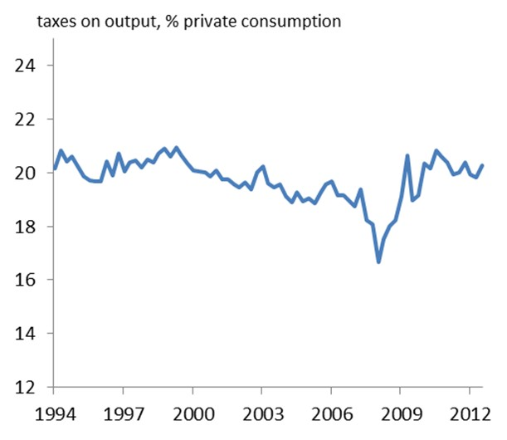 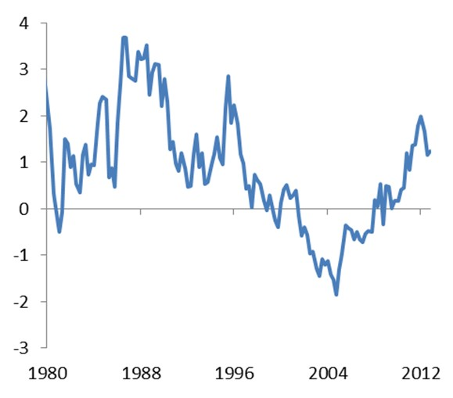

Source: ONS and own calculations Source: ONS and own calculations

One reason for that longer-term pattern is the movement in global prices. During the first ten years of inflation targeting – the so-called “NICE” decade – these moved decisively in the UK’s favour. The expansion of labour-rich economies like China, and the outsourcing opportunities they provided, led to a marked decline in the real price of traded goods. Because the UK has a structural deficit in that area – the share of tradable goods in expenditure is higher than that in output – this helped to depress the relative price of UK spending on goods. At the same time, prices of traded services, where the UK has a surplus, rose steadily. Indeed, the price of UK exports outstripped that of its imports in this area (its “terms of trade” rose).

The estimated impact on real consumer prices is shown in Chart 77. You can see the steep decline during first decade of inflation targeting, providing what Charlie Bean once described as a favourable “tailwind” for UK income.

You can also see a sharp reversal – what had been a tailwind turned into a nasty headwind – in around 2003. At least until last year, the terms of trade in services began to decline. The cost of some tradable goods, commodities in particular, started to rise. This probably reflected the other, less benign, side of the “BRICS” coin: their growing supply had lowered the cost of UK consumption, now their growing demand started to push it up.

1. Worsening relative productivity

The sharp slowdown in aggregate productivity growth in recent years is well known. What is less remarked on is that, for some time, the trend has been much worse in sectors that produce consumer goods and services than in others. Allowing for the various interconnections between sectors, Chart 8 plots productivity in the bits of the economy that supply private investment goods – machines, buildings and the like – relative to consumer-weighted productivity. For many years it declined: the consumer sector saw a relatively rapid fall in its labour costs. The opposite has been true since the end of the recession.

## Chart 8: Productivity growth has deteriorated by more in consumer-weighted sector

**Chart 9: Sharp decline in productivity of utility firms**

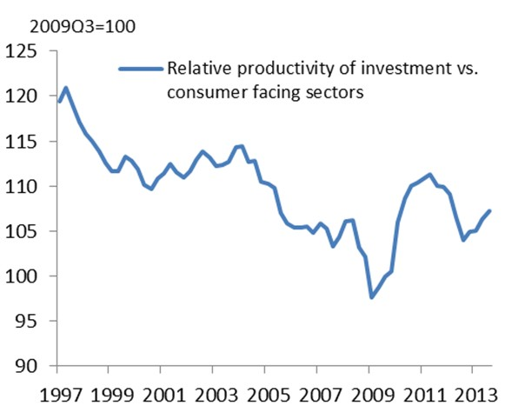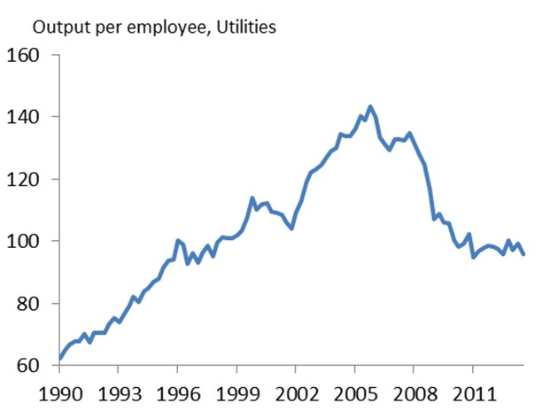

Source: ONS and own calculations Source: ONS and own calculations

I don’t think there’s any single reason for this shift. But there are some notable contributions from individual sectors. In utilities, for example, output (value-added) per employee grew strongly during the 1990s and the

7 As far as aggregate expenditure is concerned, the impact of a change in tradables prices on the relative price of expenditure to output is the same (it turns out) as its effect on the trade deficit. So the basic shape of Chart 7 is calculated as the difference between the actual deficit and what it would have been under constant real prices, taking the volumes as given. It is then scaled up to take account of the fact that, according to the UK Supply and Use tables, the share of tradables is 50% higher in private consumption than in the rest of final demand.

first half of the last decade, by over 5% a year. Over the following five years, perhaps in response to heavier regulation, it fell very sharply: employment in the sector rose by 35%, despite lower output (Chart 9).

Conversely, productivity in construction fell in the decade leading up to the recession but has risen slightly since8. This is welcome, of course9. But it does mean that the benefits of any given rate of GDP growth are felt more by buyers of investment goods, and skewed away from consumers, where domestic production costs have apparently risen more rapidly.

In summary, the relative weakness of real pay has nothing to do with a diversion of national income to profits, which have actually underperformed wages, but instead reflects adverse relative price movements for consumers. Partly thanks to a recovery in indirect taxes the jump in consumer prices has been particularly severe since the recession, but the underlying trends were in place some time before that. This is partly why, despite GDP growth of over 3% a year, real household disposable income growth averaged barely 1% in the five years leading up to the recession. It is not a new phenomenon.

There are, however, clear signs that it is beginning to fade. The effects of the earlier hikes in indirect taxes are behind us. Prices of traded goods, including commodities, have stabilised; the same appears to be true of utilities’ labour costs. And the very latest data show a sharp increase in terms of trade for UK services. This may yet be revised away. But a rise wouldn’t be out of line with the longer-term historical trend, prior to 200310. Taken together, these things appear to be bringing inflation in consumer and output prices back into line.

This is only one factor affecting real wage growth. The behaviour of firms’ margins matters too, and we can expect those to expand somewhat as the recovery matures. For given GDP this would dent real wages somewhat. But the majority of forecasters, including the MPC, also expect faster growth in the single most important determinant of average earnings, namely productivity. If, in addition, the relative price trend in Chart 5 flattens out, it is reasonable to expect real wages to start growing again.

# The composition of current growth and its future

That continuing recovery rests in part on a projected revival in business investment. Is this reasonable? Or, given the long stagnation of capital spending, should we instead expect the gap between the growth rates of business investment and GDP to be closed in a more negative manner – by means of a deceleration in aggregate demand? More generally, does the composition of expenditure – or, for that matter, income – hold any clues about the future growth of that aggregate?

8 Output per employee in construction has risen 12% in the past four years, by more than it did in the decade leading up to the recession. I briefly discussed these trends in a speech a year or so ago (Broadbent (2012)).

9 If construction productivity had continued to fall, this would have meant lower GDP growth, not faster growth of the consumption value of wages. The gap between the two would have narrowed, but not in a good way.

10 If they move in either direction, and given the UK’s comparative advantage in business and financial services, I would expect the terms of trade to rise over the future as well. The fast-growing emerging markets are undersupplied with such services. Because productivity in services tends naturally to rise less rapidly than in manufacturing, you would also expect their relative price to rise over

time.

In the long run, of course, the answer is “yes”, because an economy’s productive capacity depends on its accumulated capital, the wealth of its residents on their accumulated saving. You can see this in Chart 10. Across 121 countries it plots accumulated investment, including in “human capital” (i.e. education spending), over the last four decades of the 20th century, against per-capita GDP at the end of that period. There’s a clear correlation11.

But it’s equally clear in the short run, at least in the UK time series, that the answer is “no”. We like to tell ourselves that the composition of expenditure matters for future near-term growth – “because” consumer spending or investment in inventories are strong one year growth in aggregate demand will “therefore” be weaker the next – but, in truth, the data provide very little support for such claims.

GDP growth itself has a degree of momentum: above-average growth one year is more likely than not to be followed by above-average growth the next, albeit at a rate closer to the mean. But, for a given aggregate figure, its composition – whether of expenditure (consumption versus investment), or of income (profits versus wages) – tells you very little of statistical significance about growth the following year.

## Chart 10: Countries that invest more tend to be richer in the long run

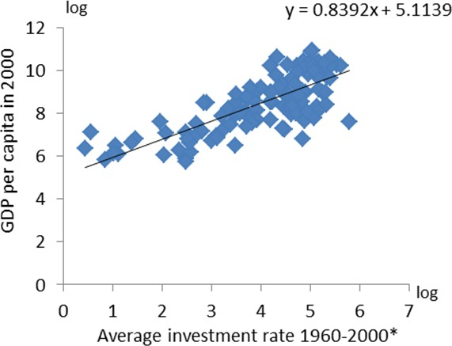

Source: Penn World Table, [www.barrolee.com](http://www.barrolee.com/)

Note: *Includes investment in human capital, as measured by average years of secondary schooling

Measurement error doesn’t help. Unavoidably, early estimates of spending and income can be significantly revised as more information comes in. The correlation between the early and mature estimates of quarterly investment growth, for example, is only 0.4. On 40% of occasions the two numbers have a different sign. That’s why, when it comes to business investment, we should pay heed not just to the early official estimates, which show a sharp contraction over the past year, but to other indicators too. Charts 11 and 12 plot official estimates of business investment growth against, respectively, a swathe of survey measures of investment intentions and firms’ spending on advertising12. Both are more positive about the recent trends.

11 See Mankiw et al. (1992).

12 Advertising doesn’t count as investment from the perspective of the economy as a whole. But for an individual firm, taking the behaviour of its competitors as given, it will have durable effects on earnings and is qualitatively similar to investment in physical

capacity. That’s why the correlation in Chart 12 is a good one: they’re driven by the same things.

## Chart 11: Business surveys more bullish about investment than official estimates

**Chart 12: Growth in advertising spending also consistent with stronger business investment**

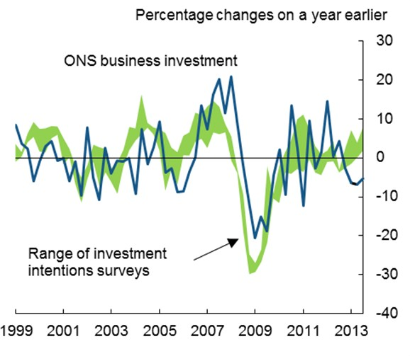 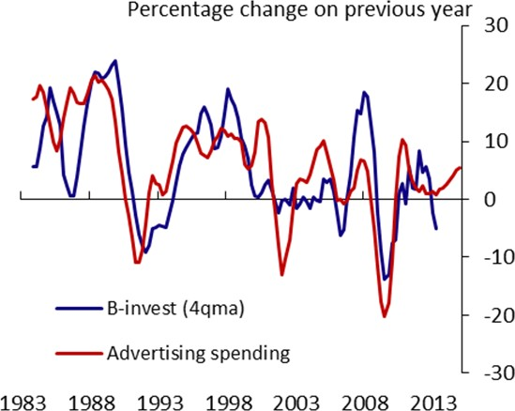

Source: ONS, Bank of England, BCC and CBI13 Source: ONS and World Advertising Research Centre

Even in mature data, however, the composition of growth hasn’t proved a good forecaster. Chart 13, for example, plots the residuals from a simple regression, using annual data, of GDP growth on its lagged value against the lagged growth in business investment.

The correlation is neither positive nor statistically significant: if you already know what happened to GDP growth itself in a particular year, the contribution of business spending doesn’t help you forecast GDP growth the following year.

The same goes for the share of profits in national income, the growth of consumption or – with one exception

* any other components of expenditure and income one can find. The first panel in Chart 14 plots t-statistics
* a measure of significance – from regressions of GDP growth on a range of indicators (each time including lagged GDP growth as a second regressor). All but one are well below the threshold for statistical significance. The exception is residential investment: matching a similar finding in US data14, this seems often to lead the economic cycle. The predictive power of UK housing starts, which obviously move in advance of residential investment, is that much greater.

13 The green shaded area includes survey measures of investment intentions from the Bank’s Agents, BCC and CBI, weighted by the relevant sectoral shares of business investment and scaled to match the mean and variance of its four-quarter growth since 1999.

14 Stock and Watson (1998).

## Chart 13: No correlation between current growth in investment and year-ahead growth in GDP

**Chart 14: Conversely, GDP is a good predictor of business investment**

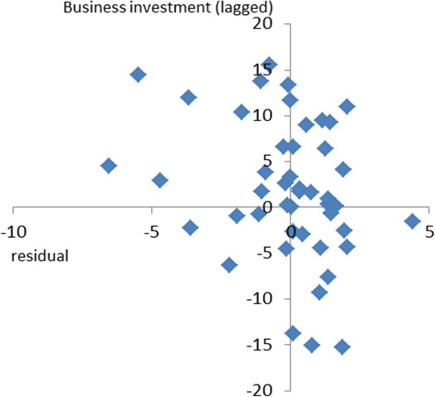 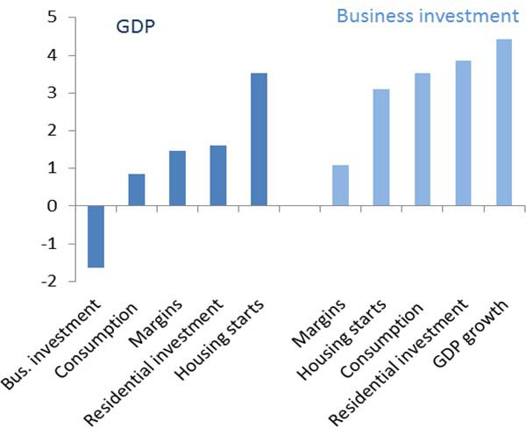

Source: ONS and own calculations Source: ONS and own calculations

What we can say, however, is that GDP predicts business investment. The bars on the right-hand side of Chart 14 also plot t-stats from simple regressions, but this time with business investment as the dependent variable. As you can see, the bar for lagged GDP growth is highly significant: business investment may not predict future economic growth, but it’s clearly predicted by it (as it is by lagged consumption and residential investment).

We should be cautious about drawing strong conclusions from this. Even though some of the relationships is significant, there’s still plenty of unexplained variation in business investment growth. The majority of the correlation between different components of expenditure is coincident, not leading or lagging. Besides, these regressions convey simple statistical correlations and don’t necessarily imply anything about causation.

If one had to hazard a guess at the underlying story, however, a simple explanation might run as follows. Cycles in the past have often been driven either by variations in monetary policy or, more generally, by variations in the supply of finance. Secured finance, both the demand for and the supply of it, might naturally respond soonest to such variations; perhaps that’s why residential investment seems (on average) to lead changes in GDP growth by a bit. The difficulties of obtaining unsecured finance, and the need to generate retained earnings to pay for it, may explain why business investment responds a bit later (it doesn’t happen till margins expand). Or perhaps businesses, many of whose investments are irreversible, simply need to see a more sustained period of economic growth before becoming sufficiently confident it will continue. My colleague Ian McCafferty will have more to say about this difference in timing in a speech next week.

Whatever the explanation, I think there’s enough here to doubt that the composition of growth is, in and of itself, a helpful forecasting variable. There well may be reasons to worry about the health and durability of any recovery, including this one. But, in and of itself, the current balance of expenditure (or income) growth isn’t one of them.

# Summary and Conclusion

The first 10 years of inflation targeting saw strong and steady growth of output and even stronger growth of real income. This “Non-Inflationary Consistently Expansionary” decade, as the last Governor described it, wasn’t just the result of an absence of big shocks or faster growth of productivity (a phenomenon most marked in the United States). At least as far as the UK was concerned, it also reflected a steady decline in the price of consumption relative to output. This allowed real spending to grow faster than real output.

As nice as the earlier decade had been, however, the following ten years have been pretty nasty. Productivity growth has been far slower, particularly since the financial crisis. For a variety of reasons, relative prices have moved against consumers. There was some brief respite during the recession. Thanks partly to a temporary cut in VAT, the purchasing power of wages was cushioned (to a degree) from the precipitous fall in output by a decline in the relative price of consumption. But indirect taxes then went back up and the earlier, more fundamental and less benign trends in real consumer prices also re-established themselves. The result has been a big jump in the price of consumption relative to the value of private-sector output, more than enough to absorb any growth in the volume of that output. Measured in terms of consumer prices, the real purchasing power of private-sector output has continued to decline.

Encouragingly, there are signs these headwinds are beginning to abate. Tradable goods prices have stabilised, the services terms of trade have recently improved (albeit on estimates still subject to revision) and there has been no further rise in indirect taxes. All this helps to explain why, despite falling unemployment and stagnant productivity, CPI inflation is back at target. Over time, of course, growth in output and real wages relies on a resumption of productivity growth. That is the single most important determinant of the trend in living standards. It’s also reasonable to expect some recovery in profit margins which, all else equal, would limit real wage growth. But it seems to me highly unlikely we’ll see anything like the relative price headwinds of the past four years. If anything, given the longer-term trends in the UK’s terms of trade, a move back in the opposite direction is a more likely prospect.

That would clearly benefit the purchasing power of UK income, wages included, supporting the real growth of consumption. Many are still concerned, however, that with business spending still stagnant – in fact, down 5% in the year to 2013Q3, according to the first official estimates – growth in aggregate demand will nonetheless subside.

I’m not sure this is a reasonable baseline view. One reason is that the near-term indicators of business investment are significantly more positive than the latest official data, which are subject to revision. Another is that the historical patterns don’t support it. In the past residential investment – which grew strongly last year – has tended to lead the cycle, business investment to lag it. That may be because unsecured finance takes longer to recover than mortgage supply, in which case retained profits – only now beginning to recover in this cycle – become disproportionately important in funding capital projects.

Finally, I have problems with an argument that treats as independent things that are actually outcomes, the result of more fundamental forces. Keynes, famously, spoke of “animal spirits” as a determinant of

private-sector investment. But the fact that confidence can wax and wane doesn’t mean that either it, or the spending that follows, are entirely arbitrary, independent of deeper economic forces. The financial crisis resulted in a savage restriction in the supply of credit and – not unreasonably – serious doubts (sometimes existential) about the future of the euro area. These were bound to hit investment very hard, and it’s since been weak everywhere in the developed world, not just the UK. Nor should we be terribly surprised, after 18 months of relative calm and a gradual thawing of credit supply, to see measures of business confidence first stabilising and then, in the most recent numbers, beginning to turn up.

There’s no guarantee that any particular cycle, including this one, is like any other. It will clearly be harder to get sustained and balanced growth in this country if the rest of the (UK-weighted) world, the euro area in particular, continues to stagnate. It will be impossible to get any sort of sustained growth, balanced or not, without an acceleration in productivity. Any growth that does come about will be worth more if the upward trend in real consumer prices really has come to an end.

It is these factors, however, not the balance of growth in and of itself, that will determine the path of the recovery and the long-awaited growth in incomes it delivers.

**References**

**Barro, R. and J. W. Lee**, 2000, "International data on educational attainment updates and implications", NBER Working Papers 7911, National Bureau of Economic Research, Inc.

**Bean C**., 2006, “Comments on Ken Rogoff: Impact of Globalization on Monetary Policy”, Speech given at Jackson Hole. Available at [**http://www.bankofengland.co.uk/archive/Documents/historicpubs/speeches/2006/speech281.pdf**](http://www.bankofengland.co.uk/archive/Documents/historicpubs/speeches/2006/speech281.pdf)

**Broadbent B**., 2013, “Deconstruction”, Speech given at Lancaster University Management School on

29 October 2012. Available at <http://www.bankofengland.co.uk/publications/Pages/speeches/2012/618.aspx>

**Carney M**, 2013, “The UK at the heart of a renewed globalisation”, Speech given at an event to celebrate the 125th anniversary of the Financial Times, London 24 October 2013. Available at <http://www.bankofengland.co.uk/publications/Documents/speeches/2013/speech690.pdf>

**Deaton, A.,** 1997. “Saving and growth”, Papers 180, Princeton, Woodrow Wilson School - Development Studies.

**Elsby, M., and B. Hobijn**, 2013, “The decline of the U.S. labour share”, Brookings Economic Studies

**Kaldor, Nicholas,** 1957, “A model of economic growth”, *The Economic Journal*, Vol. 67, No. 268, pg. 591-624.

**Layard, R., S. Nickell and R. Jackman**, 2000, “Unemployment- Macroeconomic Performance and the Labour Market”, Oxford University Press.

**Mankiw, G., D. Romer and D. Weil**, 1992, “A contribution to the empirics of economic growth”, *The Quarterly Journal of Economics*, Vol. 107, Issue 2, pg. 407-437.

**McCafferty I., 2014**, “Achieving a sustainable recovery: where next for business investment?”, forthcoming.

**Stock, J. H and M. Watson**, 1999, “Business cycle fluctuations in U. S. macroeconomic time series”,

*Handbook of Macroeconomics*”, Elsevier, (eds J. Taylor and M. Woodford)